**Ideation Phase**

**Brainstorm & Idea Prioritization Template**

|  |  |
| --- | --- |
| Date | 04 November 2022 |
| Team ID | PNT2022TMID34443 |
| Project Name | Customer Care Registry |
| Maximum Marks | 4 Marks |

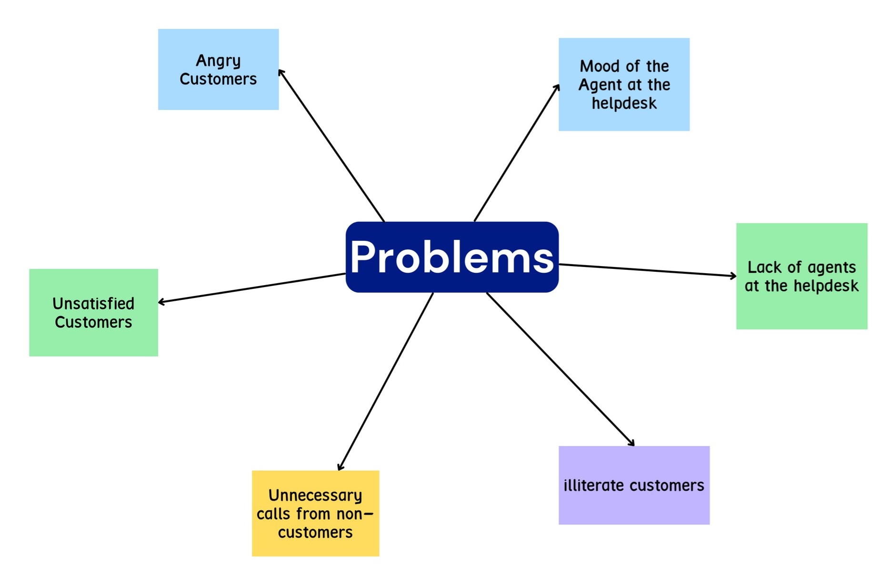**Step-1: Team Gathering, Collaboration and Select the Problem Statement**

**Defining The Problem Statement:**

To assist the customer in a better way so that he/she can clarify the doubts and get a satisfaction over the issue.

**Problems:**

**Step-2: Brainstorm, Idea Listing and Grouping**

**Steps to overcome the problem:**

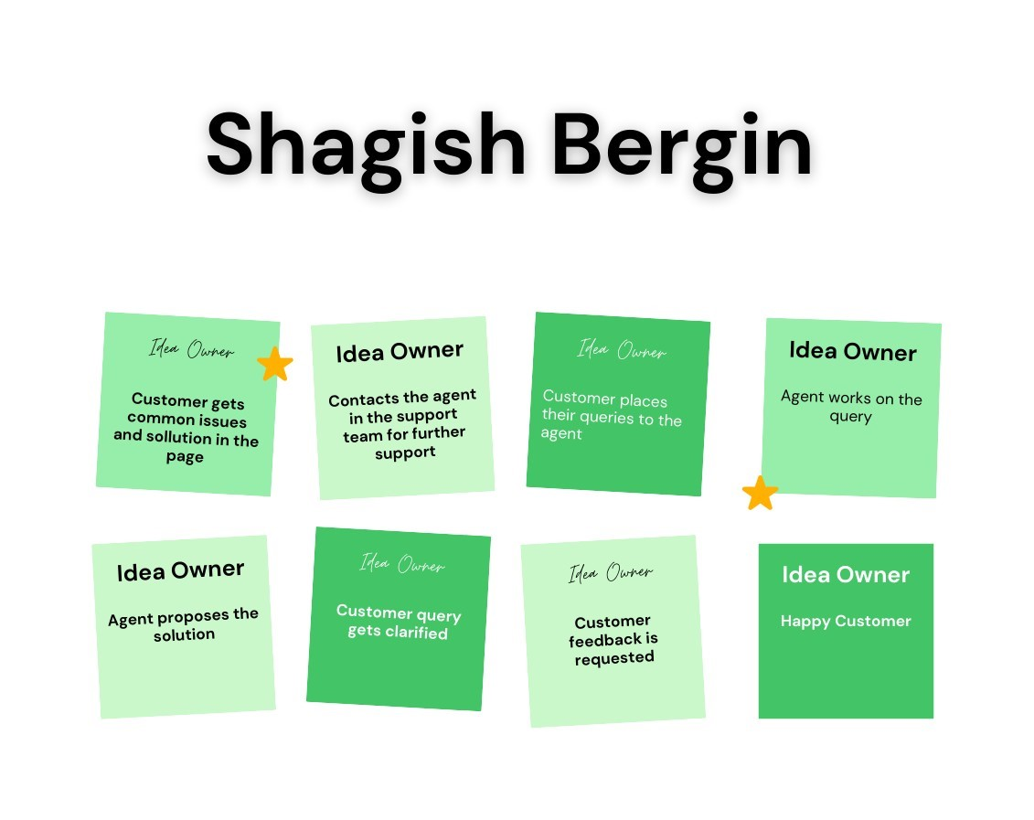

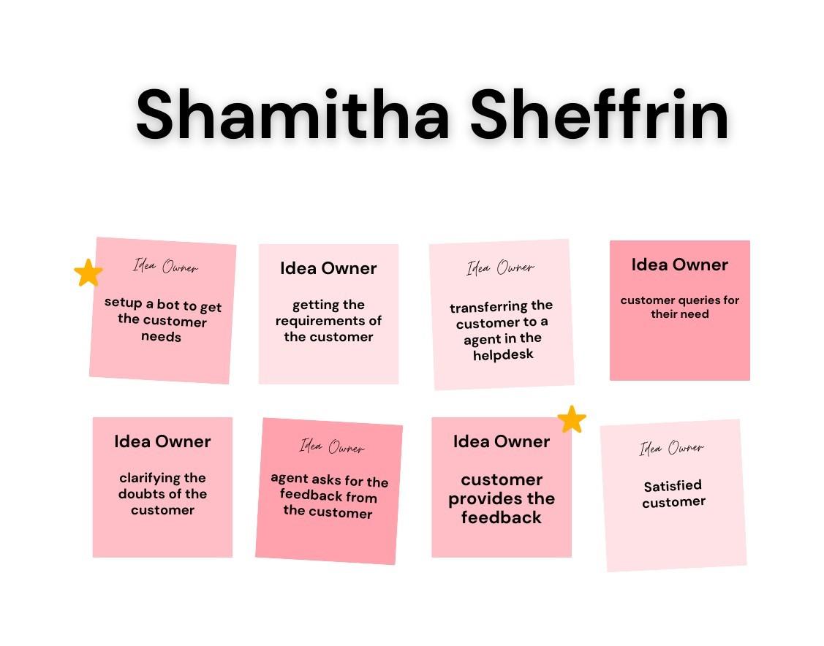

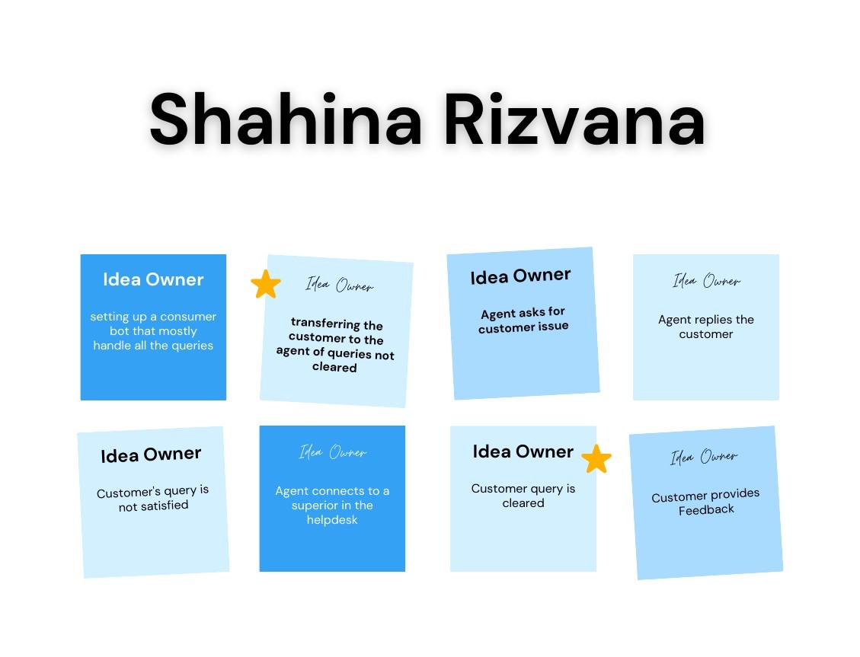

**Step-3: Idea Prioritization**

